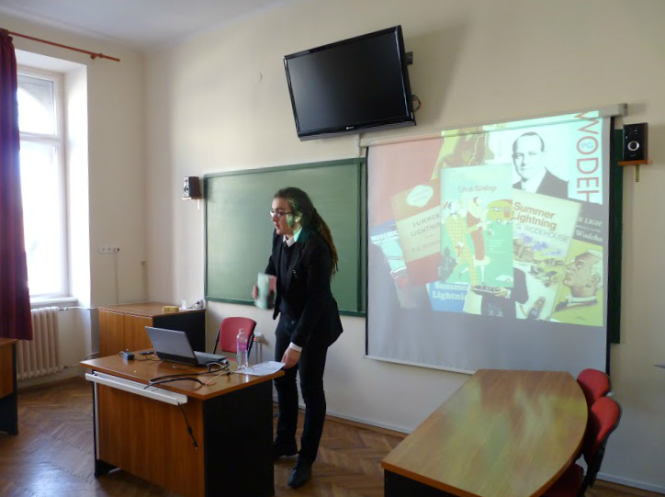
Short lecture on P. G. Wodehouse’s novel Summer Lightning and its implications
- a transcription -
Good morning, everyone! My name is Masir Bence and allow me to present a book to you here. A book that is incredibly humorous yet insightful. A book whose language is compared to that of Shakespeare yet includes street slang. A book that tells a unique story but paints a general picture of the English Aristocracy.
I am going to introduce Summer Lightning by Pelham Greenville Wodehouse.
Now, my choice may seem dubious. This is comedy here, not high literature! There are some people who consider comedy a lower form of art, but I beg to differ. Why limit ourselves? Think of the comedies of Shakespeare or Gulliver’s Travels. In order to write satire, one needs something irrational, strange, comical and absurd. I firmly believe that this book is not only entertaining, but also gives us a general idea about the real people of the real twenties.

Firstly, allow me to say a thing or two about his language. Wodehouse is a genius. I mentioned Shakespeare earlier because they often get compared. He alludes a lot too, which might be explained by his vast general knowledge. He quotes philosophers, poets and writers regularly. „But that way she has of drawing her breath in sharply and looking starry-eyed whenever your name is mentioned is enough to show me how things stand. The impression I received was of a woman wailing for her demon lover.” This, of course, has been Samuel Taylor Coleridge and his romantic masterpiece Kubla Khan. We also ought not to forget that he, after all, is a comic writer and does that very well, especially, when using his iconic similes. A writer once said that whenever he thought of writing similes, he was saddened by the fact that Wodehouse had probably already written it, only better. My favourite one is about an uncle resembling a pterodactyl with a hidden sorrow. He can mix High English with ’20s street lingo too. Listen „to this: I once got engaged to his daughter Honoria, a ghastly dynamic exhibit who read Nietzsche and had a laugh like waves breaking on a stern and rockbound coast.” Who, if not Wodehouse, can place the expression ’ghastly dynamic exhibit’ next to the very words ’a laugh like waves breaking on a stern and rockbound coast’? His usage of the iconic ’20s slang is very important here, because it reassures us that his book is a zeitgeist, an accurate picture, a blueprint.
The notion which outlines my main point is the following:
„Introduce a representative work of art, which, to your judgement, incorporates the most important questions, beliefs and problems of a certain period in history!”
Summer Lightning shows us the internal struggles of the upper classes in Britain in the ’20s. And when I say internal, I also mean that the real conflict isn’t really societal or ideological, but rather petty and interpersonal – we conclude by observing this futility. So, let us take a look at the people Sir Patrick Dean, the British ambassador of Washington labels Images of the British character we are doing our best to eradicate.
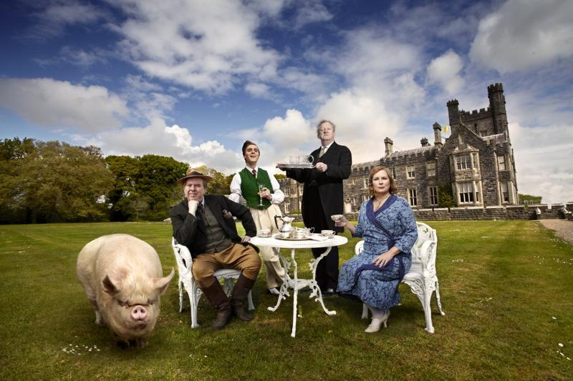
First, we have a silly, old Earl, who spends his life watching his favourite pig, the Empress of Blandings all day. Then, we have his brother, a carefree, funny chap, who focuses on collecting his reminiscences of his wanton youth. Our last stereotypical character is that of Ronnie Fish, a young gentleman not really interested in his family apart from getting money from them.
But what connects them all? Well, none of them is working or interested in it. They are all obsessed by their own, futile business, be it watching pigs feed or dancing in night-clubs. They are leading either a bohemian or a reclusive lifestyle and are generally uninterested in social, political or economic changes. Being dependant on their servants, they are misinformed about the world around them and care for nothing.
The fact that they don’t care gets only more serious if we look at what was there to be solved around the time. The pressing questions and needs are expressed in the novel either through the thoughts of the servants or the snobby attitude of their masters.
There has to be an economic reform, and we cannot leave the question of the women untouched. What if all those protesters at the suffrage movement are right? How can we tackle the problems of the poorest among us? Why are we letting big families to live unimaginably luxurious lives while there is starvation? What shall we do is a person want to marry out of his class? Should we let London grow even bigger?
Now, someone at this point may come and tell me that I’m projecting this into the book and this is only the way I think – but I beg to differ. I agree, Wodehouse’s books are innocently humorous and sweet, but they still remain critical, they are satirical after all. The only thing we need to do is not expect unforgiving and straightforward manifestos from a comic writer.
The aforementioned problems manifest themselves in the plot in the following way:
The struggle of the lovers Millicent & Hugo and Ronnie & Sue show the collision of love and tradition. Hugo and Sue are not upper class, their lovers, Millicent and Ronnie are.
There is also the conflict between the country and the city – the nobility of Shropshire or Worcestershire is, as Wodehouse says in the novel, taken up by the lack of intellectual stimulus has caused their mind to reach a state of feebleness which borders with insanity” and the nobility of the capital is decadent and depraved. There is no alternative.
The difference of class has already been touched upon, but it is noteworthy that in the novel, the servants, butlers and valets are always smarter than their masters.
The women are also revolutionary characters, because most solutions come from them. They have the brains and the will to act, only they are held back initially by the men.
Wodehouse’s parody is unforgiving and tells us all about this. We may now conclude that Summer Lightning is a work of art, worthy of appreciation from a literary standpoint and a good representation of the decadent nobility, the women & lower classes wanting changes and the general social atmosphere of the late ’20s, which, if I recall correctly, fits the criteria.
I’ve been Masir Bence, thank you for listening.

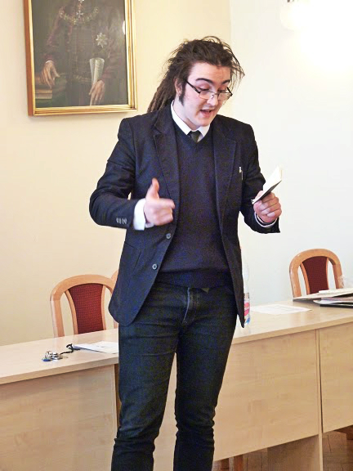
On why Stephen Fry is eligible for the Nobel Prize
Good afternoon everyone, my name is Masir Bence and let me begin with an apology: I am terribly sorry that I am no to be thorough in this presentation, but the brevity of the given time allows me only to do so much.
If I could, I would like to nominate Stephen Fry for the Nobel Peace Prize. Now, the reasons for this – to me – are very clear, but allow me to explain it to you as well.
Stephen Fry is a 57-year-old Englishman, part Jewish and part Hungarian, he visited our country several times, by the way, tracing his origins. He is a writer, actor, a public speaker, TV and radio personality, thinker and polyglot.

But why is it exactly that I would like him to be granted the Nobel Peace Prize? Well, because his deeds in several cases and fields gesture towards peace and acceptance. I am now going to list what I think his most important actions were to achieve peace.
He is a gay right activist, he himself is homosexual and recently married Elliot Spencer, but that doesn’t really matter – what matters is, that he does not think only about himself. He is selfless and altruistic in the sense that even though in England he can marry his partner in a same-sex marriage, he still cares for those, living in different parts of the world, can’t. He’s made several documentaries in Muslim countries, Uganda, South American countries and Russia. In some of these places, the legal case for homosexuality is death penalty, so it is very important for us to recognise the need for acceptance in this case.
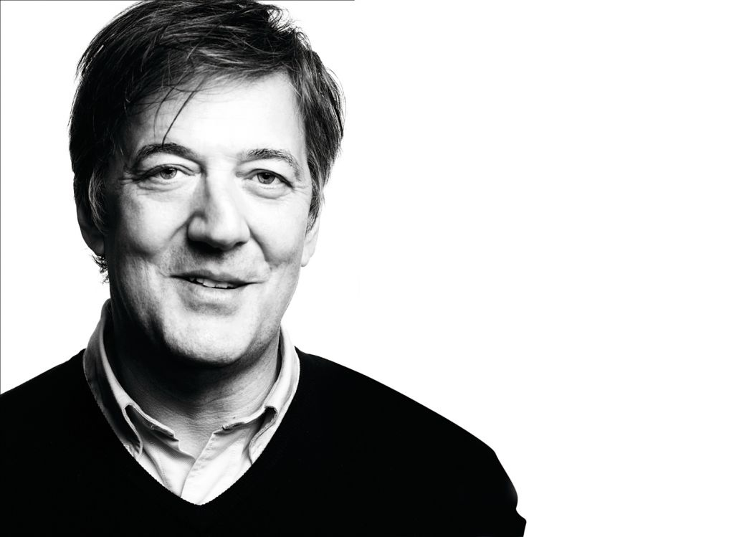
He is also a founder of the movement to pardon Allan Turing, which since then has been done, 2009 by the British Government, 2013 by the Queen herself. Allan Turing was the homosexual man who practically won the Second World War for Britain. This can be seen, should you be interested, in the great movie ’Imitation Game’, Turing’s played by Benedict Cumberbatch.
He also defended children in cases of child abuse and spoke against the exploitation and oppression of women in Western and non-Western countries alike.
He is an atheist speaker, which is very important because he has spoken out for the rights of the non-religious in theocracies, like in the ever-radicalising Muslim world, he spoke against genital mutilation, stoning of the apostates or radical religious cults. In the public religion debate, he’s been praised for representing reason and science and for scrupulously criticising corruption.
So, I would like him to be nominated for the Nobel Peace Prize, because he has spoken out before on behalf of the poor, the weak, the oppressed, the defenseless, for those, who do not - cannot – exercise their rights to claim peace and safety for themselves. He fought homophobia, the xenophobic, anti-Semitism and racism, and he fought them well.
But what I deed most important – because of its reach – is his usage of the public media. Because, unlike many others, who like to sneer and mock in their time on television or radio, Stephen Fry has called out for peace.
Thank you.

